2025
Alister Fernandes
Business/Data Analyst
4/15/2025
KYC Data Quality Dashboard
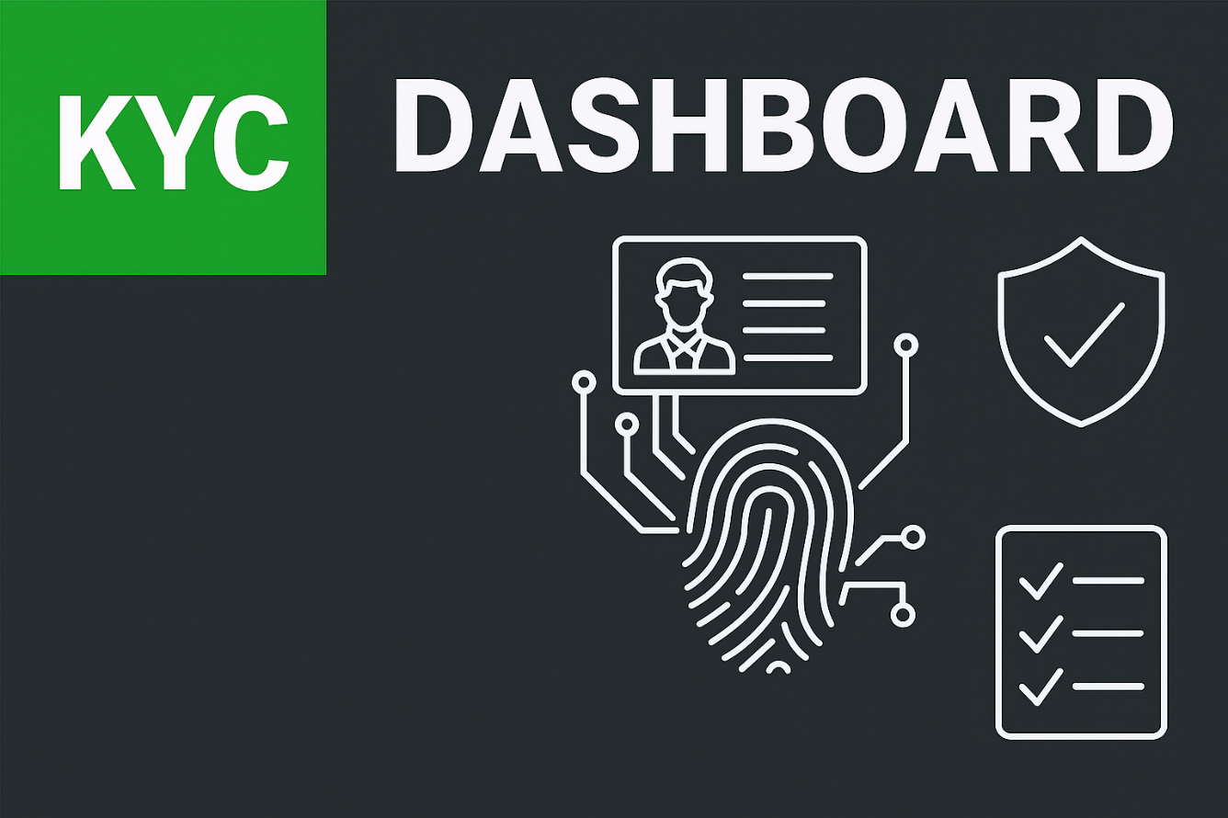

Table of Contents
0
Project Charter 2
1. Project Overview 2
2. Objective 2
3. Background 2
4. Scope 3
5. Stakeholders 3
6. Timeline 3
7. Risks & Mitigation 3
Business Requirements Document (BRD) 4
1. Project Overview 4
2. Business Problem 4
3. Goals 4
4. Success Criteria 5
5. Business Rules 5
Functional Requirements Document (FRD) 6
1. Overview 6
2. Functional Requirements Table 6
3. Additional Notes 7
Non-Functional Requirements (NFR) 8
1. Overview 8
2. Non-Functional Requirements Table 8
3. Compliance References 9
4. Review & Maintenance 9
Non-Functional Requirements (NFR) 10
1. Additional Notes 10
Source-to-Target Mapping (STTM) 11
1. Additional Notes 12
Dashboard Design Document (Page-by-Page) 13
Page 1 – Executive Board 13
Page 2 – Analyst View 14
Page 3 – KYC Compliance Drilldown 15
Page 4 – Data Quality Trends 16
Page 5 – Tool Panel 17
Technical Architecture 18
1. Overview 18
2. Data Flow 18
18
3. Transformations 19
4. Data Model 19
5. Refresh Process 20
6. Tools & Technologies 20
7. Security Architecture 20
8. Performance Considerations 21
9. Maintenance & Change Management 21
Data Model & DAX Measures 22
1. Overview 22
2. Data Model Structure 22
3. Core DAX Measures 22
4. Supporting Calculated Columns 23
5. Design Considerations 23
Incremental Refresh Strategy 24
1. Overview 24
2. Configuration Details 24
2.1. Setup Steps: 24
2.1.1. Source File Location: 24
2.1.2. Parameters Created in Power BI Desktop: 24
2.1.3. Filter Applied in Power Query: 24
2.1.4. Policy Defined in Power BI Service: 25
2.1.5. Refresh Schedule: 25
2.1.6. Data Update Process: 25
3. Benefits 25
4. Maintenance & Monitoring 25
5. Best Practices 25
Test Plan & Test Cases 26
1. Overview 26
2. Scope 26
3. Test Execution Notes 26
4. Test Case Categories & Examples 26
4.1. Data Load & Connectivity 26
4.2. Data Transformation & Validation Rules 26
4.3. KPI & Metric Accuracy 27
4.4. Filters, Slicers & Navigation 27
4.5. Incremental Refresh 27
4.6. Export & Sharing 27
4.7. Non-Functional Tests 27
4.8. Error Handling 27
User Guide 28
1. Purpose 28
2. Accessing the Dashboard 28
3. Navigating Between Pages 28
4. Using Filters and Slicers 28
5. Interpreting KPIs 28
6. Exporting Data 29
7. Refresh Frequency 29
8. Role-Specific Tips 29
9. Troubleshooting 29
10. Support & Feedback 29
Change Log 30
1. Purpose 30
2. Version History 30
3. Change Control Notes 30
Appendices 31
1. Validation Rule Definitions 31
2. Power Query M Code for Incremental Refresh 31
3. Branding Guidelines 31
4. Audit & Refresh Tracking Matrix 32
Data Update SOP – KYC Data Quality Dashboard 33
1. Purpose 33
2. Scope 33
3. Responsibilities 33
4. Procedure 33
5. Quality Checks 34
6. Troubleshooting 34
7. Change Control 34
Lessons Learned & Future Enhancements 35
1. Lessons Learned 35
2. Future Enhancements 35

Project Charter

Project Overview
The KYC Data Quality Dashboard project was initiated to address critical compliance and operational challenges in managing Know Your Customer (KYC) data within the organization. Regulatory requirements demand that client records are accurate, complete, and validated against defined business rules. Historically, these checks were performed manually, resulting in inefficiencies, delayed reporting, and increased risk of non-compliance.
This project delivers a centralized, automated, and visually intuitive Power BI dashboard that ingests client data from a controlled Excel source stored in Google Drive, applies four core validation rules, and presents results through interactive KPIs, charts, and drill-down tables. The solution is designed to serve both business stakeholders — who require high-level compliance insights — and data analysts — who need granular, record-level visibility for investigation and remediation.
Key features include:
- Automated Data Validation: Application of DOB Validity, Email Format, KYC Status Check, and Nationality Code rules.
- Incremental Refresh: Efficient daily updates that process only new or changed records, reducing refresh times and system load.
- Role-Specific Views: Executive summaries for leadership, detailed analysis pages for operational teams, and a tool panel for ad-hoc queries.
- Trend Analysis: Month-over-month performance tracking and projections to support proactive compliance management.
- Brand-Aligned Design: Consistent use of corporate colors, typography, and layout for professional presentation.
By implementing this dashboard, the organization gains:
- Improved Compliance Monitoring: Faster identification of high-severity failures and recurring issues.
- Operational Efficiency: Reduced manual effort in compiling and validating KYC data.
- Data-Driven Decision Making: Reliable, timely insights to guide remediation actions and policy updates.
- Scalability: A framework that can accommodate additional validation rules, new data sources, and expanded reporting needs.

Objective
To design, develop, and deploy a branded, automated Power BI dashboard that monitors KYC (Know Your Customer) data quality across all clients, enabling compliance teams to quickly identify and address data issues, reduce regulatory risk, and improve operational efficiency.

Background
KYC compliance is a critical requirement in the financial services industry. Current processes rely heavily on manual checks, which are time-consuming, prone to human error, and lack real-time visibility. This project automates validation checks, centralizes reporting, and provides actionable insights.

Scope
- In Scope:
  - Data ingestion from Excel source file stored in Google Drive (synced locally for refresh)
  - Application of 4 validation rules to client records
  - Dashboard visuals for KPIs, trends, and drill-downs
  - Incremental refresh configuration in Power BI
  - User training and documentation
- Out of Scope:
  - Manual data entry processes
  - Integration with external APIs
  - Real-time streaming data feeds

Stakeholders
- Business Owner: [Name] – Compliance Manager
- Data Analyst: Alister Fernandes
- Business Analyst: Alister Fernandes
- IT Support: [Name]
- Compliance Team: End users of the dashboard

Timeline
Phase | Start Date | End Date
Requirements Gathering | 2025-04-01 | 2025-04-05
Development | 2025-04-06 | 2025-04-15
Testing (UAT) | 2025-04-16 | 2025-04-20
Go-Live | 2025-04-25 | 2025-04-25

Risks & Mitigation
Risk | Impact | Mitigation
Source file structure changes | High | Lock schema, communicate changes via change control
Gateway downtime | Medium | Configure redundancy, monitor refresh logs
User adoption resistance | Medium | Provide training and quick reference guides

Business Requirements Document (BRD)

Project Overview
This document outlines the business context, objectives, and high-level requirements for the KYC Data Quality Dashboard project.
It captures the why behind the initiative — the compliance challenges, operational inefficiencies, and risk factors that the dashboard is designed to address.
The BRD defines:
- The scope of work and intended deliverables
- The stakeholders involved and their roles
- The success criteria from a business perspective
It ensures all parties have a shared understanding of the project’s purpose and expected outcomes, serving as the foundation for aligning technical delivery with business goals, enabling informed decision-making, and guiding prioritization throughout the project lifecycle.

Business Problem
The current KYC data quality verification process is manual, time-consuming, and prone to human error.
Key issues include:
- Delayed reporting due to manual compilation of data from multiple sources
- Inconsistent validation of client records, leading to gaps in compliance
- Limited visibility into trends and recurring issues
- Increased regulatory risk and potential penalties for non-compliance
These challenges result in inefficient use of analyst time, slower remediation of data issues, and reduced confidence in compliance reporting.

Goals
The KYC Data Quality Dashboard aims to:
- Automate validation checks for all client records against defined business rules.
- Provide visual KPIs for real-time compliance monitoring.
- Enable drill-down to client-level details for targeted remediation.
- Reduce manual reporting time by at least 50%, freeing resources for higher-value tasks.
- Standardize validation logic to ensure consistent application across all records.
- Support proactive compliance management through trend analysis and forecasting.

Success Criteria
The project will be considered successful if it meets the following measurable outcomes:
- Accuracy: ≥ 95% match between automated validation results and manual checks.
- Timeliness: Dashboard refresh completes within 1 hour of source file update.
- Usability: Users can filter by date, rule, and client ID without performance degradation.
- Adoption: ≥ 80% of compliance team members report positive feedback in post-implementation survey.
- Coverage: 100% of active client records are included in validation checks.
- Audit Readiness: Dashboard outputs can be exported and used directly for audit evidence.

Business Rules
- All client records must pass four core validation rules: DOB Validity, Email Format, KYC Status Check, and Nationality Code.
- Records failing any rule are flagged for review and included in the “Invalid” dataset.
- Validation timestamps must reflect the most recent check performed.
- Only authorized users with appropriate role-based permissions can access the dashboard.
- All validation logic must be transparent and documented for audit purposes.
- Any changes to validation rules must follow a formal change control process.

Functional Requirements Document (FRD)

Overview
The Functional Requirements Document (FRD) translates the business needs defined in the Business Requirements Document (BRD) into detailed, actionable specifications for the KYC Data Quality Dashboard.
It defines what the system must do to meet business objectives, covering:
- Data ingestion from approved sources
- Transformation and validation logic to enforce business rules
- Visualization requirements for KPIs, charts, and tables
- User interactions including filters, slicers, and drill-downs
- Navigation flows between report pages
- Incremental refresh rules for performance optimization
- Data export capabilities for audit and operational use
By providing a clear, testable set of functional requirements, this document ensures that developers, analysts, and testers work from a common blueprint, reducing ambiguity, supporting efficient delivery, and enabling accurate validation during User Acceptance Testing (UAT).

Functional Requirements Table

Req ID | Description | Priority | Acceptance Criteria
FR-001 | System must validate client data against 4 rules: DOB Validity, Email Format, KYC Status Check, and Nationality Code | High | Validation results match manual checks with ≥ 95% accuracy
FR-002 | Dashboard must allow filtering by date, rule, and client ID | Medium | Filters apply within ≤ 2 seconds and update all relevant visuals
FR-003 | Dashboard must display KPIs for Total Clients, % Valid, and % Invalid | High | KPI cards update automatically on refresh and match manual calculations
FR-004 | Incremental refresh must load only new or changed records | High | Refresh completes in ≤ 2 minutes and does not reload unchanged historical data
FR-005 | Dashboard must support export of detailed tables | Medium | Exported file matches on-screen data, respects applied filters, and is available in .xlsx and .csv formats
FR-006 | Dashboard must provide drill-through from summary visuals to client-level detail pages | Medium | Drill-through navigation works for all KPIs and charts without errors
FR-007 | Dashboard must display trend analysis for validation pass rates over time | Medium | Trend visuals accurately reflect historical data and match source calculations
FR-008 | Dashboard must highlight high-severity failures visually | High | High-severity records are flagged with conditional formatting in tables and charts
FR-009 | Dashboard must allow role-based access to different views | High | Users only see pages and data permitted by their assigned role
FR-010 | Dashboard must log refresh history and errors | Medium | Refresh logs are accessible to admins and include timestamps, status, and error details

Additional Notes
- Data Sources: Primary source is an Excel file stored in Google Drive, synced locally for gateway access.
- Data Model: Star schema with fact table (validation_results) and dimension tables (clients, rules).
- Refresh Schedule: Daily at 06:00 EST via incremental refresh; manual refresh available for admins.
- Security: Role-based access control (Viewer, Analyst, Admin) enforced via Power BI Service.
- Branding: All visuals must adhere to corporate style guidelines (colors, fonts, logo placement).

Non-Functional Requirements (NFR)

Overview
This section defines the quality attributes, performance benchmarks, and operational constraints for the KYC Data Quality Dashboard. While the Functional Requirements Document (FRD) specifies what the system must do, the NFRs focus on how the system should perform in production to ensure it is reliable, secure, scalable, and user-friendly.These requirements will guide development, testing, and operational monitoring, ensuring the dashboard meets both business and technical expectations.

Non-Functional Requirements Table

Category | Requirement | Target / Metric | Rationale
Performance | Dashboard page load time | ≤ 5 seconds for 95% of users | Ensures quick access to insights without delays
 | Incremental refresh duration | ≤ 2 minutes for daily refresh | Minimizes downtime and optimizes resource usage
 | Query response time (filters/slicers) | ≤ 2 seconds for standard queries | Supports smooth user interaction
Availability | System uptime during business hours | ≥ 99% | Guarantees consistent access for compliance monitoring
 | Scheduled refresh frequency | Daily at 06:00 EST | Ensures data is up to date for morning reviews
Scalability | Data volume handling | Up to 1M records without performance degradation | Supports future growth in client base
 | Rule expansion capacity | Add up to 10 new validation rules without redesign | Allows for evolving compliance needs
Security | Access control | Role-based access (Viewer, Analyst, Admin) | Protects sensitive client data
 | Data encryption | In-transit (TLS 1.2+) and at-rest encryption | Meets regulatory compliance standards
 | Audit logging | All data refreshes and access events logged | Supports compliance audits and investigations
Usability | Branding consistency | 100% adherence to corporate style guide | Maintains professional presentation
 | Accessibility compliance | WCAG 2.1 AA | Ensures usability for all users, including those with disabilities
 | Navigation clarity | ≤ 3 clicks to reach any key report page | Improves efficiency for end users
Maintainability | Update process | New data sources or rules integrated within 5 working days | Ensures agility in adapting to changes
 | Documentation currency | All technical and user documentation updated within 2 days of change | Keeps knowledge base accurate
Reliability | Data accuracy | ≥ 99% match between source and dashboard | Maintains trust in reported metrics
 | Error handling | All refresh or query errors logged and alerted within 15 minutes | Enables rapid troubleshooting

Compliance References
- ISO 27001 – Information Security Management
- GDPR – General Data Protection Regulation (if applicable to client data)
- Internal Data Privacy Policy – Organization-specific guidelines
- WCAG 2.1 AA – Web Content Accessibility Guidelines for accessibility compliance

Review & Maintenance
- NFRs will be reviewed quarterly or after any major system change.
- Updates will be version-controlled and communicated to all stakeholders.
- Any changes to NFRs must be approved by both business and technical owners before implementation.

Non-Functional Requirements (NFR)

The Data Dictionary defines each field used in the KYC Data Quality Dashboard’s data model. It ensures consistent understanding of data elements across business, technical, and compliance teams, and serves as a reference for development, testing, and audit purposes.
Field Name | Description | Data Type | Format / Allowed Values | Example
client_id | Unique identifier assigned to each client record | Integer | Positive whole number, no duplicates | 1023
client_name | Full legal name of the client | Text | Alphabetic characters, may include spaces and hyphens | Yuki Nakamura
nationality | Client’s nationality code based on ISO 3166-1 alpha-2 standard | Text | Two uppercase letters | JP
kyc_status | Current KYC compliance status of the client | Text | Verified, Pending, Failed, In Review | Verified
rule_id | Identifier for the validation rule applied | Integer | 1–4 (mapped to rule_name) | 3
rule_name | Descriptive name of the validation rule | Text | DOB Validity, Email Format, KYC Status Check, Nationality Code | DOB Validity
is_valid | Result of the validation check | Boolean | TRUE (pass), FALSE (fail) | TRUE
validation_timestamp | Date and time when the validation was performed | Date/Time | YYYY-MM-DD hh:mm:ss | 2025-09-04 10:15:00
severity | Severity level of the failure (if any) | Text | High, Medium, Low, None | High

Additional Notes
- Primary Keys: client_id + rule_id together form a composite key in the fact table.
- Data Source: All fields are sourced from the validated Excel file stored in Google Drive (synced locally for gateway access).
- Validation Logic: is_valid is derived from applying the corresponding rule_name to the client record.
- Severity Assignment: Determined by business rules — e.g., KYC Status Check failures are High severity, Email Format failures are Low severity.
- Timestamp Standardization: All dates/times stored in UTC and converted to EST for reporting.
Source-to-Target Mapping (STTM)
The Source-to-Target Mapping defines how each field from the source dataset is transformed and loaded into the Power BI data model.
It ensures consistency, traceability, and transparency in the ETL (Extract, Transform, Load) process.
Source Field | Transformation  Logic | Target  Field | Source  Data Type | Target  Data Type | Notes / Business Rules
client_id | Direct  mapping | client_id | Integer | Integer | Primary key component; must be unique and non-null
client_name | Direct  mapping | client_name | Text | Text | Full legal name; preserve case and spacing
nationality | Map ISO  code to  full country name via  lookup table | Nationality | Text (2-char code) | Text  (full country name) | Must match ISO 3166-1 alpha-2 standard; invalid codes flagged
kyc_  status | Direct  mapping | kyc_status | Text | Text | Allowed values: Verified, Pending, Failed, In Review
rule_  id | Direct  mapping | rule_id | Integer | Integer | Foreign key to rules dimension table
rule_  name | Lookup from  rule_id  in rules  dimension table | rule_name | Text | Text | Must match predefined rule list (DOB Validity, Email Format, etc.)
is_  valid | Convert Y/N  to Boolean TRUE/FALSE | is_valid | Text (Y/N) | Boolean | TRUE = Pass, FALSE = Fail
validation_  date | Format to  YYYY-MM-DD  and rename to validation_timestamp | validation_  timestamp | Date | Date/  Time | Store in UTC; convert to EST for reporting
severity | Derived from rule failure type via mapping table | severity | Text | Text | High = critical compliance breach; Medium = moderate; Low = minor

Additional Notes
- Primary Key: Composite of client_id + rule_id in the fact table.
- Data Validation: All transformations include validation checks; invalid or unmapped values are flagged for review.
- Lookup Tables:
  - Country Codes Table for nationality mapping
  - Rules Table for rule_id → rule_name mapping
  - Severity Mapping Table for assigning severity levels
- Error Handling: Any transformation errors are logged with record ID, field name, and error type.
- Change Control: Any updates to transformation logic must be documented and approved before deployment.

Dashboard Design Document (Page-by-Page)
This section describes each page of the KYC Data Quality Dashboard, detailing its purpose, visual components, layout, interactivity, and business use. The design ensures that each audience — from executives to analysts — has access to the right level of information for their role.

Page 1 – Executive Board
Purpose: Provide a high-level compliance and data quality overview for senior stakeholders, enabling quick assessment of overall KYC health and identification of top failing rules.
Figure 1Executive Board
Visuals & Layout:
- KPI Cards (top row):
  - Total Clients
  - Total Audit Events
  - Clients All Valid
  - Validation Pass Rate (%)
- Bar Chart: Failures by Rule Name (DOB Validity, Email Format, KYC Status Check, Nationality Code)
- Table: Client Pass Rate (sortable by % and name)
- Line Chart: Daily Audits Over Time
- Event Type Table: Summary of audit events by type (Validation, Manual Override, etc.)
Interactivity:
- Date slicer to filter all visuals
- Rule slicer to focus on specific validation rules
- Clickable bar chart segments to filter related visuals
Business Use: Enables executives to monitor compliance performance at a glance, spot trends in rule failures, and prioritize areas for intervention.

Page 2 – Analyst View
Purpose: Provide analysts with a detailed operational view to investigate validation performance and identify recurring issues.
Figure 2 Analyst View
Visuals & Layout:
- KPI Cards:
  - Average Client Pass Rate
  - Total Audit Events
  - Total Validations
- Bar Chart: Failed Validations by Rule (True/False split)
- Table: Client Audit Summary (Client ID, Name, Event Count, Failures)
- Line Chart: Audit Events Over Time (monthly trend)
- Map or Table: Client by Nationality (optional geographic insight)
Interactivity:
- Drill-through from summary visuals to client-level detail
- Multi-select filters for rule, severity, and nationality
- Hover tooltips showing additional metrics
Business Use: Allows analysts to pinpoint problem areas, investigate specific clients, and prepare remediation reports.

Page 3 – KYC Compliance Drilldown
Purpose: Enable compliance officers to review failed validations in detail, assess severity, and prioritize remediation actions.
Figure 3-Compliance Drilldown
Visuals & Layout:
- KPI Cards:
  - Average Client Pass Rate
  - High Severity Count
  - Clients with Manual Override
- Matrix Table: Rule Severity Breakdown (High, Medium, Low counts per rule)
- Detailed Table: Client Failures (Client ID, Name, Nationality, KYC Status, Failed Rule, Timestamp, Failure Count)
- Donut/Pie Chart: Event Type Distribution (Validation, Manual Override, Flag Raised, Update)
Interactivity:
- Filter by severity level
- Drill-through to client history from failure table
- Export option for filtered failure lists
Business Use: Supports targeted remediation by showing who failed, why, and how severe the issue is, enabling compliance teams to act quickly.

Page 4 – Data Quality Trends
Purpose: Provide trend analysis for forecasting and continuous improvement in KYC data quality.
Figure 4Data Quality Trends
Visuals & Layout:
- KPI Cards:
  - Pass Rate This Month (%)
  - Pass Rate Last Month (%)
  - Projected Next Month Pass Rate (%)
- Line Chart: Validation Pass Rate Over Time (daily or monthly)
- Bar Chart: Failure Count by Month and Rule
- Table: Client Failures by Rule (sortable and filterable)
Interactivity:
- Time period slicer for trend analysis
- Rule filter to isolate specific validation rules
- Hover tooltips with month-over-month % change
Business Use: Helps identify whether interventions are improving data quality, supports forecasting, and informs compliance strategy.

Page 5 – Tool Panel
Purpose: Serve as a utility page for power users to perform ad-hoc analysis, apply complex filters, and export data.
Figure 5, All slicer panel
Visuals & Layout:
- KPI Cards:
  - Total Validations
  - Total Audit Events
  - Pass Rate Last Month (%)
  - Projected Next Month Pass Rate (%)
  - High Severity Count
- Bar Chart: Failed Validations by Rule
- Filter Panel: Multiple slicers for date, rule, nationality, severity, and event type
Interactivity:
- All slicers affect all visuals on the page
- Export buttons for filtered datasets
- Reset filters button for quick clearing
Business Use: Acts as a sandbox for analysts and compliance officers to run custom queries, extract filtered datasets, and perform deeper investigations without affecting the main report pages.
Technical Architecture

Overview
The technical architecture defines the end-to-end flow of data, the tools and technologies used, and the operational setup for the KYC Data Quality Dashboard.
It ensures the solution is scalable, secure, and maintainable, while meeting the performance and compliance requirements outlined in the NFR.

Data Flow
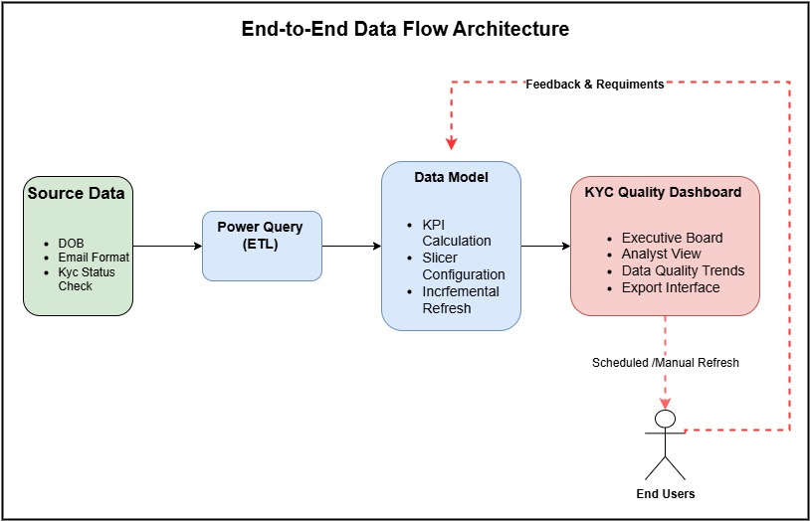
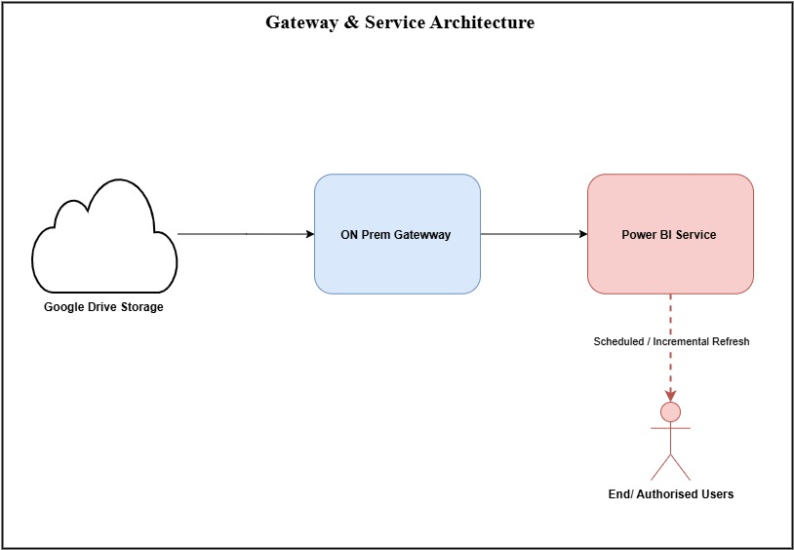
Figure 6 End-to-End Data Flow Architecture

Figure 7 Gateway & Service Architecture
Textual Flow:
- Source Data Storage – Excel file stored in Google Drive.
- Local Sync – Google Drive for Desktop syncs file to secure local folder.
- Data Ingestion – Power BI Desktop connects to local path.
- Transformation – Power Query applies validation logic, lookups, formatting.
- Data Modeling – Star schema with fact and dimension tables.
- Publishing – Model published to Power BI Service workspace.
- Consumption – Users access via browser or Power BI app.

Transformations
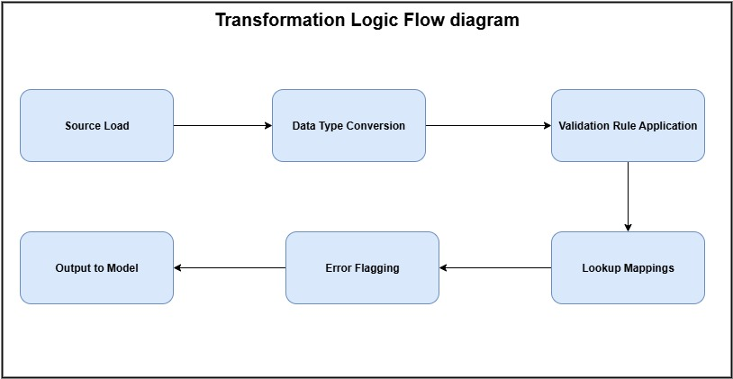
Figure 8 Transformation Logic Flow
Details:
- Validation Rules: DOB Validity, Email Format, KYC Status Check, Nationality Code.
- Lookups: ISO country codes, rule names, severity mapping.
- Error Handling: Invalid or unmapped values flagged for review.

Data Model
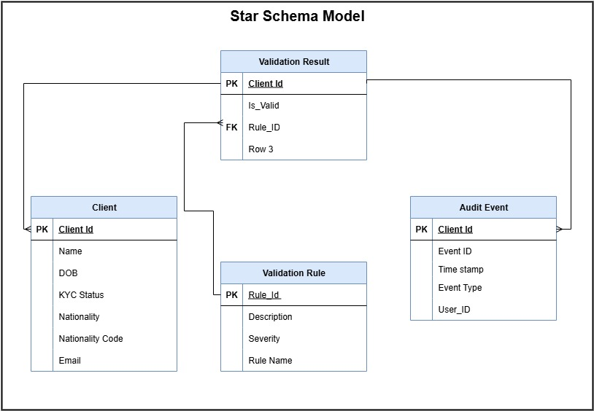
Figure 9 Star Schema Model
Details:
- Fact Table: Stores validation results per client per rule.
- Dimensions: Provide descriptive attributes for filtering and grouping.
- Keys: client_id and rule_id form composite key in fact table.

Refresh Process

Figure 10 Incremental Refresh Workflow
Details:
- Incremental Refresh: Filters on validation_timestamp to process only recent data.
- Performance: Refresh completes in under 2 minutes.
- Monitoring: Refresh logs reviewed weekly.

Tools & Technologies

Component | Technology | Purpose
Data Storage | Google Drive (Excel) | Source data repository
Local Sync | Google Drive for Desktop | Syncs source file to local gateway path
Data Transformation | Power Query (M) | Cleansing, validation logic, mapping
Data Modeling | Power BI Desktop | Star schema creation, DAX measures
Data Hosting | Power BI Service | Online access, sharing, and refresh scheduling
Connectivity | On-Premises Data Gateway | Secure connection between local files and Power BI Service

Security Architecture
- Access Control: Role-based (Viewer, Analyst, Admin) in Power BI Service.
- Data Encryption: TLS 1.2+ for in-transit, Microsoft-managed encryption at rest.
- File Permissions: Source Excel file restricted to BI team and compliance officers.
- Audit Logging: All refreshes and access events logged in Power BI Service.

Performance Considerations
- Incremental refresh reduces refresh time from ~12 minutes to < 2 minutes.
- Query folding enabled in Power Query where possible.
- Optimized DAX measures to minimize calculation time.
- Aggregations used for trend analysis visuals.

Maintenance & Change Management
- Change Control: Any updates to validation rules, data sources, or transformations require documented approval.
- Versioning: PBIX files version-controlled in secure repository.
- Monitoring: Weekly review of refresh logs and performance metrics.
- Backup: Monthly backup of source data and PBIX file.

Data Model & DAX Measures

Overview
This section documents the data model structure and the DAX measures used to calculate KPIs and metrics in the KYC Data Quality Dashboard.
It ensures that all calculations are consistent, testable, and maintainable, and that future developers or analysts can easily understand how each number is derived.

Data Model Structure
Fact Table: validation_results
- Grain: One row per client per validation rule check
- Key Fields: client_id, rule_id, is_valid, validation_timestamp, severity
Dimension Tables:
- clients (client_id, client_name, nationality, kyc_status)
- rules (rule_id, rule_name, severity)
Relationships:
- validation_results[client_id] → clients[client_id] (Many-to-One)
- validation_results[rule_id] → rules[rule_id] (Many-to-One)

Core DAX Measures

Measure Name | DAX Formula | Purpose
Total Clients | DISTINCTCOUNT(clients[client_id]) | Counts unique clients in current filter context
Total Audit Events | COUNTROWS(validation_results) | Counts all validation events
Total Validations | COUNTROWS(validation_results) | Same as Total Audit Events (used for clarity in visuals)
Clients All Valid | CALCULATE(DISTINCTCOUNT(clients[client_id]), NOT(CONTAINS(validation_results, validation_results[client_id], clients[client_id], validation_results[is_valid], FALSE))) | Counts clients with no failed validations
Validation Pass Rate | DIVIDE(CALCULATE(COUNTROWS(validation_results), validation_results[is_valid] = TRUE), COUNTROWS(validation_results)) | % of validations that passed
Average Client Pass Rate | AVERAGEX(VALUES(clients[client_id]), [Client Pass Rate]) | Average pass rate across all clients
Client Pass Rate | DIVIDE(CALCULATE(COUNTROWS(validation_results), validation_results[is_valid] = TRUE), CALCULATE(COUNTROWS(validation_results))) | Pass rate for a single client
High Severity Count | CALCULATE(COUNTROWS(validation_results), rules[severity] = "High", validation_results[is_valid] = FALSE) | Number of high-severity failures
Failures by Rule | CALCULATE(COUNTROWS(validation_results), validation_results[is_valid] = FALSE, ALLEXCEPT(rules, rules[rule_name])) | Failures grouped by rule
Pass Rate This Month | CALCULATE([Validation Pass Rate], FILTER(ALL(validation_results), MONTH(validation_results[validation_timestamp]) = MONTH(TODAY()) && YEAR(validation_results[validation_timestamp]) = YEAR(TODAY()))) | Pass rate for current month
Pass Rate Last Month | CALCULATE([Validation Pass Rate], FILTER(ALL(validation_results), MONTH(validation_results[validation_timestamp]) = MONTH(EDATE(TODAY(), -1)) && YEAR(validation_results[validation_timestamp]) = YEAR(EDATE(TODAY(), -1)))) | Pass rate for previous month
Projected Next Month Pass Rate | FORECAST.LINEAR(MONTH(TODAY())+1, [Validation Pass Rate], [MonthNumber]) | Forecasted pass rate based on historical trend
Failure Count by Month and Rule | CALCULATE(COUNTROWS(validation_results), validation_results[is_valid] = FALSE, ALLEXCEPT(rules, rules[rule_name], validation_results[Month])) | Failures grouped by month and rule

Supporting Calculated Columns

Column Name | DAX Formula | Purpose
Failure Flag | IF(validation_results[is_valid] = FALSE, "Fail", "Pass") | Used for conditional formatting
Month | FORMAT(validation_results[validation_timestamp], "MMM YYYY") | Used for monthly trend grouping
Month Number | MONTH(validation_results[validation_timestamp]) | Used in forecasting calculations

Design Considerations
- Base Measures First: Create foundational measures (e.g., Total Clients, Total Audit Events) and reuse them in composite measures to reduce complexity.
- Performance: Use CALCULATE with filters instead of iterators where possible to improve performance.
- Naming Convention: Prefix KPI measures with KPI_ for easy identification in the field list.
- Documentation: Add descriptions to each measure in the model for quick reference in Power BI.
Incremental Refresh Strategy

Overview
Incremental refresh is implemented in the KYC Data Quality Dashboard to optimize dataset refresh performance by processing only new or updated records instead of reloading the entire dataset.
This approach reduces refresh time, minimizes resource usage, and ensures the dashboard remains responsive for end-users while retaining historical data for compliance and trend analysis.

Configuration Details

Figure 11– Incremental Refresh Workflow

Setup Steps:

Source File Location:
  - Excel file stored in Google Drive.
  - Synced locally via Google Drive for Desktop to a secure folder accessible by the On-Premises Data Gateway.

Parameters Created in Power BI Desktop:
  - RangeStart (Date/Time)
  - RangeEnd (Date/Time)

Filter Applied in Power Query:
  - Applied to validation_timestamp column:
  - validation_timestamp >= RangeStart
  - and validation_timestamp < RangeEnd

Policy Defined in Power BI Service:
  - Store 5 years of historical data.
  - Refresh only the last 1 month of data daily.

Refresh Schedule:
  - Daily at 06:00 EST via On-Premises Data Gateway.
  - Manual refresh available for admins when immediate updates are required.

Data Update Process:
  - New records or changes are manually appended to the Excel file by the Data Analyst as needed.
  - No fixed cadence for data entry — updates occur when new data is available or when analyst time permits.
  - After adding new data, a manual refresh can be triggered to make it visible immediately.

Benefits
- Performance: Reduced refresh time from ~12 minutes to under 2 minutes.
- Efficiency: Minimizes load on the gateway and Power BI Service.
- Scalability: Supports growth in data volume without impacting performance.
- Audit Readiness: Historical data retained for compliance reviews.
- Flexibility: Allows ad-hoc data additions without disrupting the daily refresh cycle.

Maintenance & Monitoring
- Weekly: Review refresh logs in Power BI Service for errors or anomalies.
- Quarterly: Validate that historical data retention meets compliance and reporting needs.
- Change Control: Any updates to the refresh window, retention period, or transformation logic must be documented and approved.
- Error Handling:
  - Failed refresh triggers email alert to BI team.
  - Root cause investigated within 24 hours.
  - Issues and resolutions logged for future reference.

Best Practices
- Keep a Data Update Log tab in the source Excel file noting:
  - Date of update
  - Number of records added/modified
  - Brief description of changes
  - Initials of the person making the update
- Ensure all new rows are inside the defined Excel table range to be picked up by Power BI.
- Validate new data against the Data Dictionary before saving.
- Trigger a manual refresh after significant updates to avoid waiting for the next scheduled refresh.

Test Plan & Test Cases

Overview
The Test Plan defines the approach, scope, and specific test cases used to validate the functionality, performance, and reliability of the KYC Data Quality Dashboard. It ensures that both business requirements and non-functional requirements are met before deployment, and that the solution is stable, accurate, and user-friendly.

Scope
Testing will cover:
- Functional Requirements – As defined in the FRD (data ingestion, transformation, validation logic, KPIs, filters, navigation, export).
- Non-Functional Requirements – As defined in the NFR (performance, availability, security, usability).
- Data Integrity – Accuracy and completeness of data from source to dashboard.
- Error Handling – System behavior under failure conditions.

Test Execution Notes
- Test Environment: Power BI Service workspace connected to production-like data source.
- Test Data: Controlled dataset in Excel stored in Google Drive, synced locally for gateway access.
- Pass/Fail Criteria: All acceptance criteria must be met; any failed test must be logged, fixed, and retested.
- Documentation: Each test case will include a “Pass/Fail” column and “Tester’s Notes” for UAT tracking.

Test Case Categories & Examples

Data Load & Connectivity

Test Case ID | Description | Expected Result
TC-001 | Load dashboard with initial dataset (50 records) | All visuals populate without errors
TC-002 | Add new records to source file and refresh | New records appear in visuals after refresh
TC-003 | Test connection to Google Drive source via Gateway | Connection succeeds without credential errors

Data Transformation & Validation Rules

Test Case ID | Description | Expected Result
TC-004 | Apply DOB Validity rule to all records | Invalid DOBs flagged correctly
TC-005 | Apply Email Format rule | Invalid emails flagged correctly
TC-006 | Apply KYC Status Check rule | Non-verified clients flagged as failures
TC-007 | Apply Nationality Code rule | Non-ISO codes flagged correctly

KPI & Metric Accuracy

Test Case ID | Description | Expected Result
TC-008 | Validate “Total Clients” KPI | Matches distinct client_id count in dataset
TC-009 | Validate “Validation Pass Rate” KPI | Matches manual calculation from dataset
TC-010 | Validate “High Severity Count” KPI | Matches count of high-severity failures

Filters, Slicers & Navigation

Test Case ID | Description | Expected Result
TC-011 | Apply date slicer | Only records within range display
TC-012 | Apply rule slicer | Only selected rule’s results display
TC-013 | Apply client slicer | Only selected client’s data displays
TC-014 | Navigate between pages | All pages load without delay or error

Incremental Refresh

Test Case ID | Description | Expected Result
TC-015 | Run scheduled daily refresh | Completes in < 2 minutes
TC-016 | Verify only new/changed records processed | No reprocessing of unchanged historical data

Export & Sharing

Test Case ID | Description | Expected Result
TC-017 | Export table to Excel | Exported file matches on-screen data
TC-018 | Share dashboard link with authorized user | User can view without permission errors
TC-019 | Attempt access by unauthorized user | Access denied as per role-based security

Non-Functional Tests

Test Case ID | Description | Expected Result
TC-020 | Measure page load time | ≤ 5 seconds for 95% of users
TC-021 | Test dashboard on different devices (desktop, tablet) | Layout and visuals render correctly
TC-022 | Verify accessibility compliance | Meets WCAG 2.1 AA standards

Error Handling

Test Case ID | Description | Expected Result
TC-023 | Simulate missing source file | Dashboard displays error message, logs event
TC-024 | Simulate invalid data type in source | Record excluded or flagged without breaking visuals
User Guide

Purpose
This User Guide provides step-by-step instructions for accessing, navigating, and using the KYC Data Quality Dashboard. It is intended for all authorized users — executives, compliance officers, and analysts — to ensure consistent and effective use of the dashboard’s features.

Accessing the Dashboard
[Placeholder: Screenshot – Power BI Service Workspace Access] Description for designer: Show the workspace in Power BI Service with the KYC Data Quality Dashboard highlighted.
- Open the Power BI Service link provided by the BI team.
- Sign in with your corporate Microsoft 365 account.
- Ensure you have the correct workspace permissions (Viewer or higher).

Navigating Between Pages
[Placeholder: Screenshot – Page Tabs in Power BI] Description for designer: Show the page navigation bar with tabs for Executive Board, Analyst View, KYC Compliance Drilldown, Data Quality Trends, Tool Panel.
- Use the page tabs at the bottom of the report to switch between:
  - Executive Board
  - Analyst View
  - KYC Compliance Drilldown
  - Data Quality Trends
  - Tool Panel

Using Filters and Slicers
[Placeholder: Screenshot – Filter Panel and Slicers] Description for designer: Highlight date slicer, rule slicer, and client slicer.
- Date Slicer: Select a date range to filter all visuals.
- Rule Slicer: Focus on specific validation rules (1–4).
- Client Slicer: Narrow down to one or more clients.
- Cross-Filtering: Selecting a bar in a chart will filter related visuals automatically.

Interpreting KPIs
[Placeholder: Screenshot – KPI Cards] Description for designer: Show KPI cards with labels and values.
- Total Clients: Count of unique client IDs in the selected period.
- Validation Pass Rate: Percentage of validations that passed all rules.
- High Severity Count: Number of failures classified as high severity.
- Projected Next Month Pass Rate: Forecasted pass rate based on trend analysis.

Exporting Data
- Click the More Options (…) menu on any table visual.
- Select Export data → Choose .xlsx or .csv.
- Data will export with the current filters applied.

Refresh Frequency
- Scheduled Refresh: Data refreshes daily at 06:00 EST via incremental refresh.
- Manual Refresh: Can be triggered by the BI team if urgent.
- Note: If you add new data to the source file and want it reflected immediately, request a manual refresh rather than waiting for the next scheduled run.

Role-Specific Tips
- Executives: Focus on the Executive Board page for high-level KPIs and trends.
- Compliance Officers: Use the KYC Compliance Drilldown page to identify and act on high-severity failures.
- Analysts: Leverage the Analyst View and Tool Panel for deep dives, ad-hoc queries, and exports.

Troubleshooting
- Data Missing: Check that the date slicer includes the relevant period.
- Slow Performance: Reduce the date range or filter to fewer rules/clients.
- Access Issues: Contact the BI team to verify your permissions.
- Refresh Errors: Notify the BI administrator; check the refresh history in Power BI Service.

Support & Feedback
- Support Contact: BI Team – [Insert Email]
- Feedback: Use the “Comments” feature in Power BI Service or email the BI team with suggestions or issues.

Change Log

Purpose
The Change Log records all modifications made to the KYC Data Quality Dashboard after its initial release. It provides a version history for audit purposes, supports change management, and ensures all stakeholders are aware of updates to functionality, data, or design.

Version History

Date | Version | Change Description | Author
2025-09-22 | 1.0 | Initial release of KYC Data Quality Dashboard | Alister Fernandes
2025-09-25 | 1.1 | Added Rule 4 validation and updated visuals | Alister Fernandes
2025-10-05 | 1.2 | Integrated new client dataset (500 records) | Alister Fernandes
2025-10-20 | 1.3 | Added Address Completeness validation rule | Alister Fernandes

Change Control Notes
- Version Numbering: Major changes increment the first digit (e.g., 2.0), minor enhancements or fixes increment the second digit (e.g., 1.4).
- Approval Process: All changes must be reviewed and approved by the BI team lead before deployment.
- Documentation: Each change entry should be accompanied by updated technical and user documentation where applicable.
- Impact Assessment: For each change, assess potential impacts on data accuracy, performance, and user experience.

Appendices

Validation Rule Definitions
Purpose: To define the business logic for each validation rule applied to client records in the KYC Data Quality Dashboard. These rules ensure data quality and compliance with regulatory standards.
- DOB Validity
  - Checks if the date of birth is present, valid, and within a logical range (e.g., age between 18 and 100).
  - Failure triggers a Medium severity flag.
- Email Format
  - Validates that the email address follows standard format rules (e.g., name@domain.com).
  - Failure triggers a Low severity flag.
- KYC Status Check
  - Ensures the client’s KYC status is “Verified” in the source system.
  - Failure triggers a High severity flag.
- Nationality Code
  - Confirms that the nationality code matches the ISO 3166-1 alpha-2 standard.
  - Failure triggers a Medium severity flag.

Power Query M Code for Incremental Refresh
Purpose: To filter the dataset during refresh so that only records within the defined refresh window are processed, improving performance and efficiency.
m
let
Source = Excel.Workbook(File.Contents("C:\Data\KYC_Data.xlsx"), null, true),
Clients_Table = Source{[Name="clients"]}[Content],
ChangedType = Table.TransformColumnTypes(Clients_Table,{{"validation_timestamp", type datetime}}),
FilteredRows = Table.SelectRows(
ChangedType,
each [validation_timestamp] >= RangeStart and [validation_timestamp] < RangeEnd
)
in
FilteredRows
Notes:
- RangeStart and RangeEnd are Date/Time parameters defined in Power BI.
- This filter ensures only data within the refresh window is processed.
- Historical data retention and refresh window are configured in the Power BI Service.

Branding Guidelines
Purpose: To ensure consistent visual presentation and alignment with corporate identity standards.
- Font: Segoe UI for all visuals and text boxes.
- Primary Color: Scotiabank Red (#EC111A).
- Secondary Color: Dark Grey (#4D4D4D).
- Accent Color: Light Grey (#F2F2F2) for table backgrounds.
- Logo Placement: Top-left corner of each page.
- KPI Card Style: Bold metric, smaller descriptive label, consistent background color.
- Chart Formatting:
  - Axis labels in dark grey
  - Gridlines minimized for clarity
  - Data labels enabled for key metrics

Audit & Refresh Tracking Matrix
Purpose: To track planned and completed audit, refresh, and data increment activities for the KYC Data Quality Dashboard.
Entry ID | Planned Date | Activity Type | Description / Scope | Data Source(s) Affected | Owner / Responsible | Status | Notes / Outcomes
001 | 2025-10-01 | Audit | Full KYC data quality audit – all 4 rules | validation_results, clients | Compliance Analyst | Planned | First post-go-live audit
002 | 2025-10-05 | Increment | Add 500 new client records from onboarding | clients | Data Analyst | Planned | Ensure nationality codes match ISO list
003 | 2025-10-07 | Refresh | Scheduled daily refresh check | All tables | BI Developer | Recurring | Verify incremental refresh runs < 2 min
004 | 2025-10-15 | Audit | Rule 3 (KYC Status) deep dive | validation_results | Compliance Officer | Planned | Focus on high-severity failures
005 | 2025-10-20 | Increment | Add new validation rule: Address Completeness | rules, validation_results | Data Analyst | Planned | Update FRD & Data Dictionary
006 | 2025-10-25 | Refresh | Monthly full refresh test | All tables | BI Developer | Planned | Compare with incremental results
Usage Notes:
- Keep this table updated after each activity.
- Use Status to track progress (Planned, In Progress, Completed).
- Add Notes / Outcomes after completion to capture findings and follow-up actions.
- This matrix can be connected to Power BI as a “Project Tracker” table for visual monitoring.

Data Update SOP – KYC Data Quality Dashboard

Purpose
To define the standard process for updating the source Excel file stored in Google Drive and ensuring the KYC Data Quality Dashboard reflects the latest data through scheduled or manual refresh.

Scope
Applies to all updates made to the KYC_Data.xlsx file that feeds the Power BI dashboard, including new client records, updated validation results, and changes to existing records.

Responsibilities
- Data Analyst (Alister Fernandes):
  - Add or update data in the source file.
  - Maintain the Data Update Log tab in the Excel file.
  - Trigger manual refresh when needed.
- BI Administrator:
  - Monitor scheduled refreshes.
  - Troubleshoot refresh failures.

Procedure

Step 1 – Access the Source File
- Open Google Drive in your browser or via Google Drive for Desktop.
- Navigate to the secure folder containing KYC_Data.xlsx.
- Open the file in Excel (desktop version preferred for large updates).

Step 2 – Add or Update Data
- Insert new client records at the bottom of the relevant table.
- Ensure all required fields are populated:
  - client_id, client_name, nationality, kyc_status, rule_id, rule_name, is_valid, validation_timestamp, severity.
- Follow the Data Dictionary for correct formats and allowed values.
- For updates to existing records, locate the row and make changes directly — do not duplicate client_id + rule_id combinations.

Step 3 – Update the Data Update Log
- Go to the Data Update Log tab in the Excel file.
- Record:
  - Date of update
  - Number of records added/modified
  - Brief description of changes (e.g., “Added 250 new onboarding clients”)
  - Your initials

Step 4 – Save and Sync
- Save the Excel file.
- Confirm Google Drive for Desktop syncs the updated file to the local gateway path (check sync icon).

Step 5 – Refresh the Dashboard
- If waiting for scheduled refresh: No action needed — dashboard will update at 06:00 EST.
- If immediate update needed:
  - Go to Power BI Service.
  - Navigate to the dataset.
  - Click Refresh Now.
  - Verify refresh completion in the dataset’s refresh history.

Quality Checks
- After refresh, open the dashboard and confirm:
  - New records appear in visuals.
  - KPIs reflect updated counts.
  - No unexpected spikes or drops in metrics.
- If anomalies are found, review the source file for data entry errors.

Troubleshooting
- Refresh fails: Check gateway connection and file path.
- Data missing: Ensure new rows are inside the defined Excel table range.
- Incorrect values: Verify against Data Dictionary and STTM.

Change Control
- Any structural changes to the source file (e.g., new columns, renamed fields) must be documented and approved before implementation.
- Update the Data Dictionary and STTM accordingly.

Lessons Learned & Future Enhancements

Lessons Learned
Purpose:
To capture key takeaways from the project that can inform future dashboard development and process improvements.
- Incremental Refresh Efficiency: Reduced refresh time from ~12 minutes to under 2 minutes, improving performance and user experience.
- Data Consistency: Consistent field naming and data types in the source file prevented schema errors during refresh.
- Stakeholder Engagement: Early and continuous involvement of compliance and analytics teams ensured the dashboard met both regulatory and operational needs.

Future Enhancements
Purpose:
To outline potential improvements and new features that could increase the dashboard’s value and scalability.
- API Integration: Connect to API feeds for near real-time data updates.
- Predictive Analytics: Add forecasting models to predict compliance risk trends.
- Expanded Validation Rules: Include checks for address completeness, phone number format, and document expiry dates.
- Row-Level Security (RLS): Implement RLS in Power BI to restrict sensitive client data to authorized users only.

